**ENGR 4020 Lab 4 [25 pts]**

**Optical Encoders[1]**

**Demonstrate by 2/26/2020**

**Submit by 2/27/2020**

**Tasks**

You are given the following encoder wheel. Your goal is to use the markings on the wheel to sense the magnitude and direction of rotation of the disk.

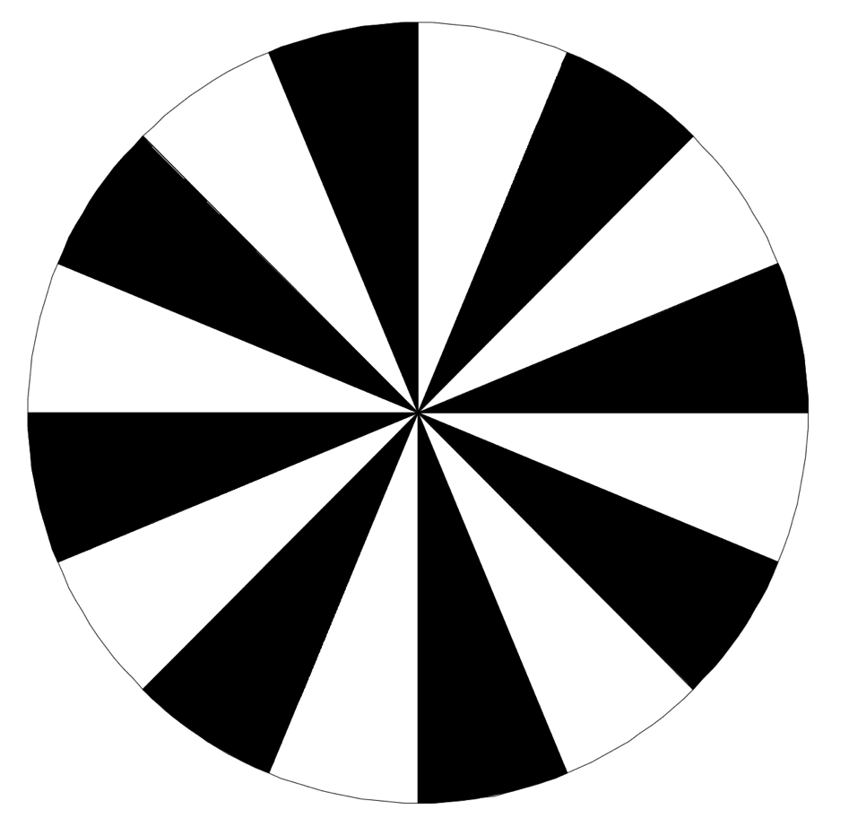

**Figure 1:** Optical encoder disc for Lab exercise.

In order to use this disc as an optical quadrature encoder, you will need to put two reflective photo sensors on your breadboard with sufficient spacing to produce quadrature waves when the disc is rotated. You will need to keep wires flush with the breadboard so that they do not restrict locating the disc close to the sensors. The first objective is to demonstrate that quadrature waves are received on the oscilloscope. A screenshot of the oscilloscope demonstrating this is required in your lab notebook.

The second objective is to write code for the mbed which will read the outputs of the two reflective photosensors to two digital ports and display the encoder count and absolute rotation to the serial terminal. The monitor should count up if the disc is spun in the clockwise direction and count down if the disc is spun counterclockwise. The program should be able to handle and display both positive and negative numbers.

**Requirements**

1. Document this lab exercise in your lab notebook, including any circuits and code generated. You must also include the screenshot of the oscilloscope with quadrature waves displayed.
2. Demonstrate functionality of the encoder to the instructor by the due date.
3. Submit your code as .cpp files on Canvas.

1. Adapted from ENGR 450: Mechatronics at Roger Williams University by Matthew Stein